Experiment [5]: [Shell Programming]

### Name: Tushita Sharma ,Roll.: 590029121 ,Date: 2025-09-20

### AIM:

* [To Learn Basic Conditional Statements in Bash Scripting]

### Requirements:

* [Any Linux Distro, any kind of text editor (vs code, vim, notepad, nano, etc)]

### Theory:

* [Basic usage of conditions and arrays in bash scripting.]

## Procedure & Observations

## Exercise 1: [Prime Number Check]

## Task Statement:

* [To check if the number given by the user is a prime number or not.]

## Explanation:

* [using if else loop wap to check if the number is a prime number or not.]

## Command(s):

#!/bin/bash  
echo "Enter a number: "  
read num  
flag=0  
  
for ((i=2; i<=num/2; i++))  
do  
 if [ $((num % i)) -eq 0 ]  
 then  
 flag=1  
 break  
 fi  
done  
  
if [ $flag -eq 0 ]  
then  
 echo "$num is a prime number."  
else  
 echo "$num is not a prime number."  
fi

### Output:

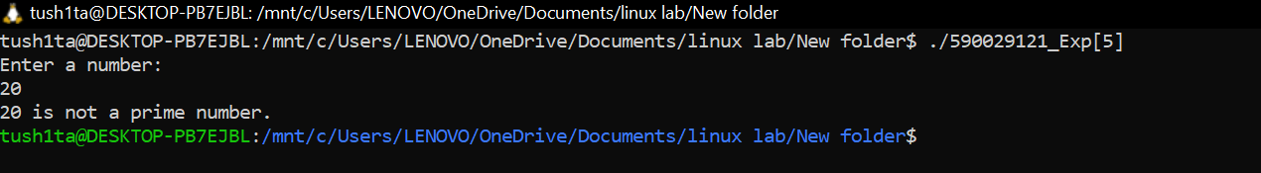

## Exercise 2: [Sum of Digits]

## Task Statement:

* [Take input from user and give the sum of two digits.]

## Explanation:

* [This script will take input from user and will give the following output.]

## Command(s):

#!/bin/bash  
echo "Enter a number: "  
read num  
sum=0  
  
while [ $num -gt 0 ]  
do  
 digit=$((num % 10))  
 sum=$((sum + digit))  
 num=$((num / 10))  
done  
  
echo "Sum of digits: $sum"

### Output:

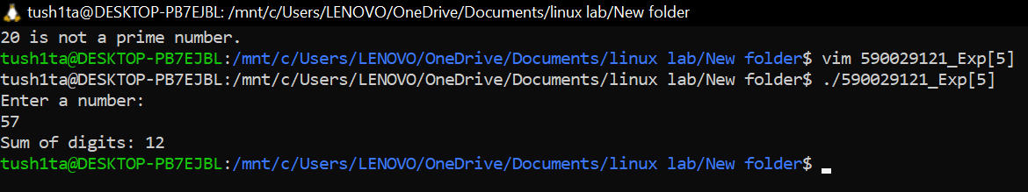

## Exercise 3: [Armstrong Numbers]

## Task Statement:

* [Take input user and give the sum of Armstrong number of n digits is a number equal to the sum of its digits raised to the power n. Example: 153 = 13 + 53 + 33 ]

## Explanation:

* [This script will tell if the number entered by the user is an armstrong number or not.]

## Command(s):

#!/bin/bash  
echo "Enter a number: "  
read num  
temp=$num  
n=${#num} # number of digits  
sum=0  
  
while [ $temp -gt 0 ]  
do  
 digit=$((temp % 10))  
 sum=$((sum + digit**n))  
 temp=$((temp / 10))  
done  
  
if [ $sum -eq $num ]  
then  
 echo "$num is an Armstrong number."  
else  
 echo "$num is not an Armstrong number."  
fi

### Output:

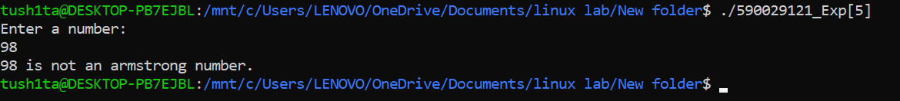

## Result:

* The Exercises were successfully completed for Basic Shell Scripting.